

Bachelor of Computer Applications
Semester – V
Deep Learning

Project – 06
Title: Simple Neural Network Forward Propagation

Submitted By:
Poojashree H
Reg. No.: 2411021240046
Date: 27/09/2026

Submitted To:

Faculty Name: Nagasri p

Department of Computer Application Alliance University
Chandapura - Anekal Main Road, Anekal Bengaluru – 562106

SEPTEMBER 2026

Objective

The objective of this project is to build a simple neural network and understand the process of forward propagation how input data moves through a network's layers, gets transformed by weights, biases, and activation functions, and results in a final prediction. The Iris flower classification dataset is used as the basis for this demonstration.
Dataset Description

The Iris dataset is a classic dataset used in machine learning, containing 150 samples of iris flowers belonging to three species: Setosa, Versicolor, and Virginica. Each sample has four numerical input features:
Sepal length (cm)
Sepal width (cm)
Petal length (cm)
Petal width (cm)
The target variable represents the flower species, encoded as 0 (Setosa), 1 (Versicolor), or 2 (Virginica).

Methodology

Data Preparation (Task 1)

The dataset was loaded using scikit-learn's built-in load_iris() function. Since the four features are measured on different scales, StandardScaler was applied to standardize them to zero mean and unit variance. This ensures that no single feature dominates the network's computations simply due to a larger numeric range.

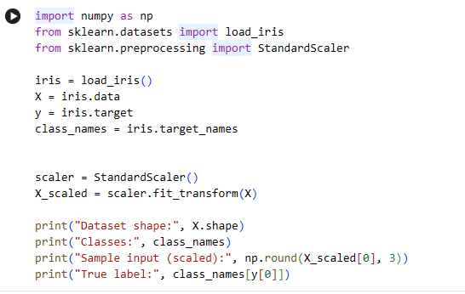

Network Architecture and Forward Propagation (Task 2)

A simple two-layer neural network was designed with the following structure:

Layer | Neurons | Description
Input Layer | 4 | One neuron per input feature
Hidden Layer | 5 | Fully connected, Sigmoid activation
Output Layer | 3 | Fully connected, Softmax activation

Weights (W1, W2) and biases (b1, b2) were randomly initialized. Forward propagation computes each layer as a linear transformation followed by a non-linear activation function:
Hidden layer: Z1 = X·W1 + b1, A1 = sigmoid(Z1)
Output layer: Z2 = A1·W2 + b2, A2 = softmax(Z2)

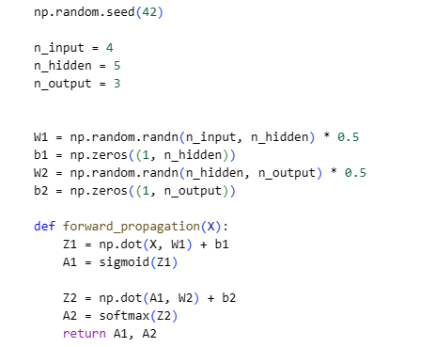

Activation Functions and Output Generation (Task 3)

Two activation functions were used:
- Sigmoid (hidden layer) - introduces non-linearity, squashing values between 0 and 1.
- Softmax (output layer) - converts raw output scores into a probability distribution across the three classes, ensuring the probabilities sum to 1.

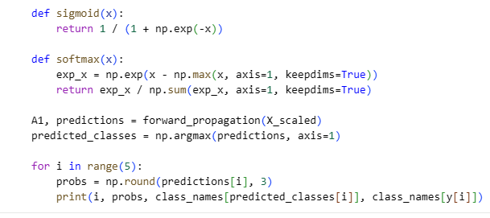

The predicted class for each sample was obtained by selecting the class with the highest probability (np.argmax).

Results

Forward propagation was run on the entire dataset. The predicted probabilities and classifications for the first five samples are shown below:

Sample | P(Setosa) | P(Versicolor) | P(Virginica) | Predicted | Actual
0 | 0.158 | 0.109 | 0.733 | Virginica | Setosa
1 | 0.179 | 0.105 | 0.716 | Virginica | Setosa
2 | 0.174 | 0.108 | 0.718 | Virginica | Setosa
3 | 0.182 | 0.112 | 0.705 | Virginica | Setosa
4 | 0.158 | 0.112 | 0.730 | Virginica | Setosa
Overall accuracy across all 150 samples: 33.33%

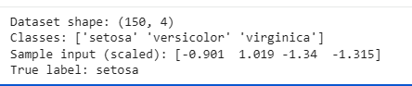

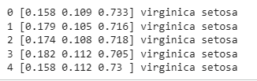

Discussion

The overall accuracy of 33.33% is close to random chance for a 3-class classification problem, which is expected. Since the network's weights were initialized randomly and never updated through training (no backpropagation or gradient descent was performed), the network has no learned knowledge of the relationship between the input features and the correct species. Every output produced is a valid probability distribution (each row sums to 1), confirming that the mathematical mechanics of forward propagation matrix multiplication, bias addition, and activation were implemented correctly.

This result reinforces an important distinction in neural networks: forward propagation defines how a network computes an output from a given input and a fixed set of weights, while learning (via backpropagation) is a separate process that adjusts those weights over multiple iterations to minimize prediction error. A network can only produce meaningful predictions after it has been trained.

Conclusion

This project successfully implemented a simple feedforward neural network and demonstrated the complete forward propagation pipeline on the Iris dataset from data loading and standardization, through a hidden layer with Sigmoid activation, to an output layer with Softmax activation producing class probabilities. While the untrained network's predictions were not accurate, the project achieved its core goal: illustrating how data flows through a neural network's layers and how activation functions shape that flow, laying the foundation for understanding how training (backpropagation) would later improve these predictions.

